Overview
- What is the purpose of the Rapid Corridors Project?
The Rapid Corridors Project intends to improve reliability and travel time along Grand/West Grand Avenues, San Pablo Avenue, and Telegraph Avenue.

Public Input Information
- How can I provide input?
We will send letters to those who work, live, and/or own businesses or property close to the proposed bus stop changes. Please check the project webpage (http://www.actransit.org/rapid-corridors/telegraph-avenue/) for the project details.

You can submit your comments by:
Email: planning@actransit.org
Phone: 510-591-7262
Mail: AC Transit, Service Planning and Development Department, 1600 Franklin Street Oakland, CA 94612

Traffic Signal Improvements
- What is a Transit Signal Priority (TSP) System?
Transit Signal Priority System (TSP) allows buses to request priority upon arrival and the signal can grant additional seconds of green to reduce time spent waiting at red lights.
- Will these signal modifications benefit cyclists and motorists as well?
Buses can slow the flow of traffic due to frequent stops and reentering traffic along a street. As a result, traffic behind the buses must yield, which can result in congestion. If buses can move more effectively in and out of bus stops, traffic will be improved for all modalities. In addition, the retiming and synchronization of traffic signals will help provide adequate crossing time for people walking and bicycling through an intersection. Motorists will also benefit from reduced delay at traffic signals, improving travel time along the streets.

Bus Stop Changes
- How does AC Transit staff make decisions about bus stop relocation?
There are several factors that determine changes to an existing bus stop. Considerations include several elements, such as change in land use, bus operations, safety, and stop spacing (i.e., how close was the previous stop and how far is the next stop). Bus stop relocation helps achieve stop spacing for local and rapid bus service types as defined by AC Transit Board Policy No. 501. In addition, stops proposed to be removed are close to neighboring stops with higher ridership activity.
- What are “near-side” bus stops and “far-side” bus stops?
Near-side bus stops are located immediately before crossing an intersection. Far-side bus stops are located immediately after crossing an intersection.
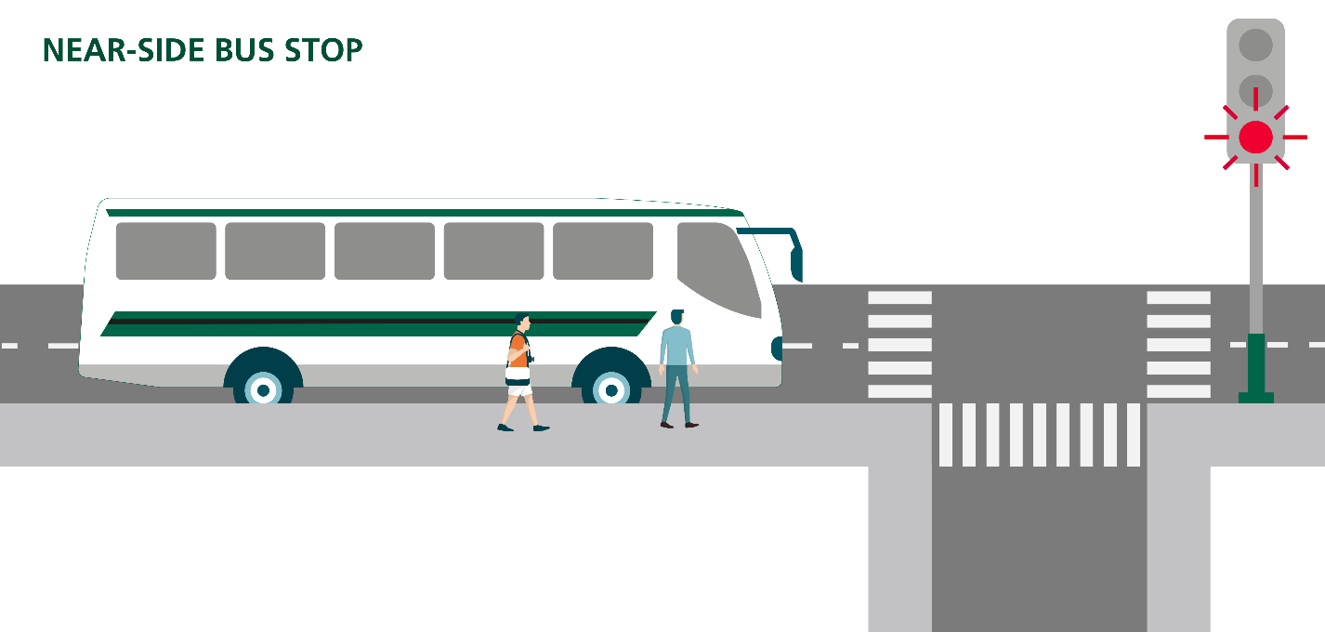
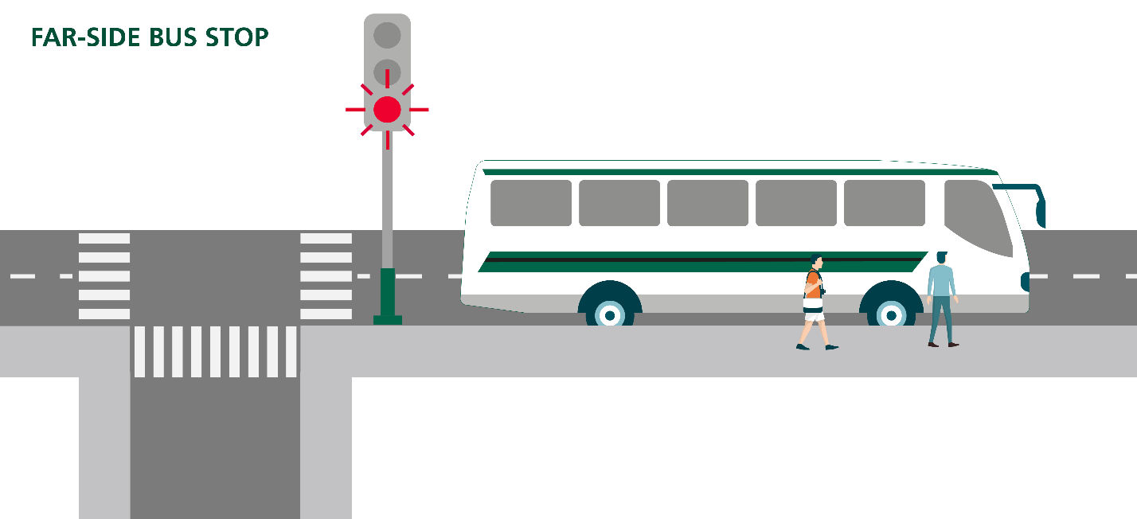
- How does a “far-side” bus stop reduce transit travel times?
When stops are on the near-side of an intersection with a traffic signal, buses may have to halt before reaching stop due to possible traffic congestion. After passengers board, buses at near-side stops have to merge back into traffic and may be stopped by a red light. By placing a bus stop on the far-side, buses can use the transit signal priority for faster travel through signalized intersections.
- What are bus stop improvements?
Bus stops improvements can include longer bus stops, relocations, consolidations, pavement of dirt planter strips, and the rebuilding of some sidewalk areas. The proposed improvements will enhance rider safety and access at bus stops. Please check the Rapid Corridors Project web page for details of the proposed improvements at specific locations.

Changes to On-Street Parking
- Will bus stops improvements affect existing parking?
Expanding and creating new bus stops will improve service and reduce transit delays and remove some parking throughout the corridor. On the other hand, bus stops removals can create the opportunity to add parking or loading spaces. Please check the Rapid Corridors Project web page for potential parking impacts at specific locations.

- Will a “far-side” bus stop relocation affect existing parking?
When relocating bus stops from near to far-side, parking is adjusted by reclaiming spaces from the previous near-side stops. A near-side stop usually requires a longer curb space for operations, while a bus will use an intersection to pull into a far-side bus stop, needing shorter length than a near-side bus stop.

Construction Impacts
- How will the bus schedule be affected?
Buses will run on our regular schedule; however, bus stop closures may occur near sites of construction work. Please subscribe to eNews for your lines and check notices posted at your stop.
- Will there be an alternate bus stop during construction?
Residents, business owners and property owners fronting construction activities will be notified approximately two weeks before the proposed construction activities. Please subscribe to eNews for your lines and check notices posted at your bus stop.

